Border Gateway Protocol Lab

Joshua Widjaja

P0-2 Cisco CCNP

Mr. Mason

**Purpose:**

The sole purpose of this lab was so that we could learn about the applicable uses of Border Gateway protocol (BGP). It familiarized us with certain concepts of BGP and how crucial it is for the functioning of the internet on a global scale. In this lab we also learned more about using the interior gateway routing protocols such as OSPF, EIGRP, and RIP. Regarding these routing protocols, we learned about their specific capabilities and how multiple autonomous systems are able to route traffic between the 3 different networks. We also learned about a few ways to use BGP’s flexibility and how to demonstrate it.

**Background Information:**

The lab was particularly centered around the concept of how BGP operates. **Border Gateway Protocol (BGP)** is an exterior gateway protocol used to help routers in one autonomous system to communicate with another autonomous system on the internet. An autonomous system is essentially a network with IP addresses using a single specific routing policy. Each network contains an Autonomous system number and is used as a unique identifier allowing its autonomous system to exchange routing information with others. BGP consists of two different types that use Autonomous Systems differently which are external BGP and internal BGP. Internal BGP is a tool that gives information about the internal routers in a single autonomous system whereas external BGP involves communication between routers in different autonomous systems. In the real world, internal BGP is commonly used in large enterprise networks while external BGP is used for connecting networks ran by different organizations. Apart from BGP, we configured different protocols such as RIP, EIGRP, and OSPF.

**Routing information protocol (RIP)** is a distance vector interior gateway routing protocol. Every RIP router contains a routing table which has all known destinations and chooses to reach them based on hop count.

**Enhanced Interior Gateway Routing Protocol (EIGRP)** is a distance vector interior gateway routing protocol. EIGRP uses five package types (metrics) which are hello packets, query packets, reply packets, request packets, and update packets. EIGRP in this way enables network administrators to accommodate shifting requirements without the need to change the network design.

**Open Shortest Path First (OSPF)** is an interior gateway link-state routing protocol. Routers using OSPF must establish neighbor relationships before exchanging routes and information about the network topology. Using the Shortest Path First algorithm, the OSPF router will calculate the best routes and add them to the routing table.

When researching the 3 attributes that could demonstrate BGP’s flexibility, we chose scan time, weight, and as-path.

**Scan time:** The scanner allows BGP to efficiently manage a large number of routing relationships. The scam time checks the status of BGP peers and the routing table. If there is an error/failure, BGP with scan time is able to quickly respond and update the routing information. We were able to adjust and configure the time intervals to change the responsiveness to network failure.

**Weight:** This cisco-proprietary attribute of BGP is used to influence the best path selection within a specific autonomous system. Since the weight attribute is the first in consideration for path selection, a higher set weight makes a route path more preferred.

**AS Path:** This attribute represents the sequence of autonomous systems and the route that was taken to reach the router you are using. AS path is used for loop prevention and making sure BGP selects the best path.

**Lab Summary:**

We first set up an IP scheme for each router’s interface (g0/0/0 and g0/0/1), setting up ipv4 addresses. We then created a topology based on our IP scheme to help us stay organized. Using the topology, we set up our cables to the matching connecting interfaces. Consoling into each router, we configured our preset ipv4 addresses on each interface we assigned the routers to. We set up 2 routers each for the OSPF, EIGRP, and RIP separate networks. For those routers on the interior connected to BGP, we configured them with BGP. We set BGP network as the backbone area and put a switch in the BGP network which connected to the interior routers configured with BGP. For each network, we configured a unique Autonomous System number. We then configured IPv4 and IPv6 routes for the different routing protocols and made sure that there was connectivity between all routers through pinging. Lastly, we searched the web for 3 special attributes that demonstrate BGP’s flexibility. We then inputted them into our network and configured them.

**Lab Commands:**

The new commands that I learned required to do this lab were for configuring BGP, EIGRP, RIP, and the 3 special attributes such as scan-time, weight, and AS Path.

**BGP:**

The command “**router bgp [AS-Number]**” enters BGP configuration mode and specifies the autonomous system number for the unique network.

The command **“address-family ipv4”** is used to configure BGP to operate with IPv4 routes. After we entered this command, we were able to enter network and neighbor commands.

The command in (config-router) “**neighbor [ip-address] remote-as [AS-Number]**” configures a BGP neighbor and specifies the autonomous system number.

The command “**bgp default-originate [route-map-name]**” advertises a default route to the specific BGP peer.

The command “**clear ip bgp**” kills the TCP session with a certain BGP neighbor, causing a reset. This command was particularly helpful in us receiving our updated prefixes from the neighbor again.

The command “**show ip bgp**” displays BGP routing information.

**EIGRP:**

The command “**router eigrp [AS-Number]**” enters EIGRP configuration mode and specifies the autonomous system number for the unique network.

**RIP:**

The command “**router rip**” enters RIP configuration mode.

The command “” generates a default route into the RIP routing domain.

**Scan-Time:**

In (config-router) mode, the command “**timers [keepalive-time] [hold-time]**” configures scan time.

**Weight:**

In (config-router) mode, the command “**neighbor [neighbor-ip] weight [weight-value]**” configures weight.

**AS Path:**

In (configure-router) mode, enter “**neighbor []neighbor-ip] route-map PREPEND_AS out/in**” and then in (config-route-map) mode, enter “**set as-path prepend [your-AS-number]**” to configure AS path.

**Network Diagram:**

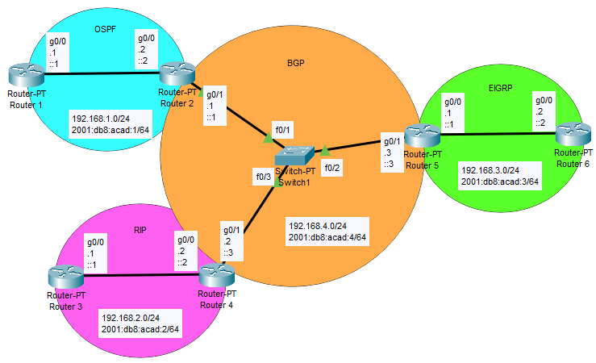

**Configurations:**

**---R1---**

R1#show run

Building configuration...

Current configuration : 1799 bytes

Last configuration change at 16:47:24 UTC Thu Jan 18 2024

version 16.9

service timestamps debug datetime msec

service timestamps log datetime msec

platform qfp utilization monitor load 80

no platform punt-keepalive disable-kernel-core

hostname R1

boot-start-marker

boot-end-marker

vrf definition Mgmt-intf

address-family ipv4

exit-address-family

address-family ipv6

exit-address-family

no aaa new-model

login on-success log

subscriber templating

vtp domain cisco

vtp mode transparent

ipv6 unicast-routing

multilink bundle-name authenticated

license udi pid ISR4321/K9 sn FDO21482HZX

license boot level appxk9

no license smart enable

diagnostic bootup level minimal

spanning-tree extend system-id

redundancy

mode none

interface GigabitEthernet0/0/0

ip address 192.168.1.1 255.255.255.0

negotiation auto

ipv6 address 2001:DB8:ACAD:1::1/64

ipv6 enable

ipv6 ospf 1 area 0

interface GigabitEthernet0/0/1

no ip address

negotiation auto

interface Serial0/1/0

no ip address

shutdown

interface Serial0/1/1

no ip address

shutdown

interface GigabitEthernet0

vrf forwarding Mgmt-intf

no ip address

shutdown

negotiation auto

router ospf 1

router-id 2.2.2.2

redistribute connected subnets

network 192.168.1.0 0.0.0.255 area 0

router bgp 1

bgp router-id 1.1.1.1

bgp log-neighbor-changes

address-family ipv6

exit-address-family

ip forward-protocol nd

no ip http server

no ip http secure-server

ip tftp source-interface GigabitEthernet0

ipv6 router ospf 1

router-id 2.2.2.2

redistribute connected

control-plane

banner motd ^Chello^C

line con 0

transport input none

stopbits 1

line aux 0

stopbits 1

line vty 0 4

login

end

**---R2---**

R2#show run  
Building configuration...

Current configuration : 4785 bytes  
Last configuration change at 16:48:49 UTC Tue Jan 2 2024  
  
version 16.9  
service timestamps debug datetime msec  
service timestamps log datetime msec  
platform qfp utilization monitor load 80  
platform punt-keepalive disable-kernel-core  
  
hostname R2  
boot-start-marker  
boot-end-marker  
  
vrf definition Mgmt-intf  
  
address-family ipv4  
exit-address-family  
  
address-family ipv6  
exit-address-family  
  
no aaa new-model  
  
login on-success log  
  
subscriber templating  
  
vtp domain cisco  
vtp mode transparent  
ipv6 unicast-routing  
multilink bundle-name authenticated  
  
crypto pki trustpoint TP-self-signed-2105456491  
enrollment selfsigned  
subject-name cn=IOS-Self-Signed-Certificate-2105456491  
revocation-check none  
rsakeypair TP-self-signed-2105456491  
  
crypto pki certificate chain TP-self-signed-2105456491  
certificate self-signed 01  
  30820330 30820218 A0030201 02020101 300D0609 2A864886 F70D0101 05050030  
  31312F30 2D060355 04031326 494F532D 53656C66 2D536967 6E65642D 43657274  
  69666963 6174652D 32313035 34353634 3931301E 170D3233 30363036 31383232  
  32395A17 0D333030 31303130 30303030 305A3031 312F302D 06035504 03132649  
  4F532D53 656C662D 5369676E 65642D43 65727469 66696361 74652D32 31303534  
  35363439 31308201 22300D06 092A8648 86F70D01 01010500 0382010F 00308201  
  0A028201 0100876A 184F35C6 0E929121 EE3811A8 28E1A40F FD6DDB23 539E0D71  
  8E7E6090 3554D474 46DF5C06 8E68CDAC B1FF1F90 ACF8D30E 20CD2F18 A3D2A9D8  
  AC5627B9 D2163758 C17AEB01 07A8C0CF 3C9C8CF9 ED7074F9 02991FB8 1E7409DD  
  74AEB5A2 40DC020A 5DE53722 7FFD0381 BD09A39C 11C123E4 BE55D472 1607DBD8  
  987513C4 03E13D0D B539E73B 7DF22B0C 7C34FEC8 89133906 8F3BB98B 6D8AD20E  
  0A490E56 48B00F73 80D3F9E9 A8B16B4D 64A6C0B4 C5C65E75 8FEAF49C 2B49687F  
  B150A1EC 6873780E 1AADEF00 CE9F01A6 17C6382D 4D71B2E6 1E4C78DA 5A46E715  
  3EE04254 0DC6B096 180F1EF5 FC4BE073 C1B9221D 3A4C9F87 C15B7860 0EF18D3E  
  54B842D5 0ABD0203 010001A3 53305130 0F060355 1D130101 FF040530 030101FF  
  301F0603 551D2304 18301680 1440DDFF E73B2EAD ED3921BA A11AEE2E 6D45A59B  
  59301D06 03551D0E 04160414 40DDFFE7 3B2EADED 3921BAA1 1AEE2E6D 45A59B59  
  300D0609 2A864886 F70D0101 05050003 82010100 5B8F2495 D377BC11 0B345122  
  96F7CB9A 8003892D F80D3933 C744DFE8 D0C85690 A020EF0C D378F115 D2DFFBD5  
  7A915909 82581749 596387CB B7E832DF CBD3E80B 9C03DB26 DA183114 57E74C7D  
  27386F78 F616A79F 984C1F31 CEEBFC5A A7899161 15D25D18 0E3E64C0 1451C28A  
  E591F4F3 121F95BC E482E801 2886D58F 4B704519 75E997BC 751FCFA9 8C0FD4B5  
  707B872B BAAE459F A94760DE 290E7468 C566D6E4 C2E9AB64 DCD64D7E E4C533E1  
  02C26C97 342238B1 985B5E18 A43B10B3 69E0A5ED 30796592 C66037AE DAFA667A  
  782B7257 3E033740 86EB13DD 6D60C50E C84D2F03 0CF888C6 D1356561 7DB99621  
  79DC8347 077D1D63 E20BC2A1 AF6EC6E2 81F3D397  
        quit  
  
license udi pid ISR4321/K9 sn FDO21482DWJ  
license boot level appxk9  
no license smart enable  
diagnostic bootup level minimal  
  
spanning-tree extend system-id  
  
redundancy  
mode none  
  
interface GigabitEthernet0/0/0  
ip address 192.168.1.2 255.255.255.0  
negotiation auto  
ipv6 address 2001:DB8:ACAD:1::2/64  
ipv6 enable  
ipv6 ospf 1 area 0  
  
interface GigabitEthernet0/0/1  
ip address 192.168.4.1 255.255.255.0  
negotiation auto  
ipv6 address 2001:DB8:ACAD:4::1/64  
ipv6 enable  
  
interface Serial0/1/0  
no ip address  
shutdown  
  
interface Serial0/1/1  
no ip address  
shutdown  
  
interface GigabitEthernet0  
vrf forwarding Mgmt-intf  
no ip address  
shutdown  
negotiation auto  
  
router ospf 1  
router-id 1.1.1.1  
redistribute connected subnets  
redistribute bgp 1 metric 1 subnets  
network 192.168.1.0 0.0.0.255 area 0  
  
router bgp 1  
bgp log-neighbor-changes  
bgp default local-preference 200  
timers bgp 5 20  
neighbor 2001:DB8:ACAD:4::2 remote-as 2  
neighbor 2001:DB8:ACAD:4::3 remote-as 3  
neighbor 192.168.4.2 remote-as 2  
neighbor 192.168.4.3 remote-as 3  
  
address-family ipv4  
  bgp scan-time 20  
  network 192.168.4.0  
  redistribute connected  
  redistribute ospf 1  
  no neighbor 2001:DB8:ACAD:4::2 activate  
  no neighbor 2001:DB8:ACAD:4::3 activate  
  neighbor 192.168.4.2 activate  
  neighbor 192.168.4.2 weight 200  
  neighbor 192.168.4.3 activate  
  neighbor 192.168.4.3 weight 300  
exit-address-family  
  
address-family ipv6  
  redistribute connected  
  network 2001::/64  
  neighbor 2001:DB8:ACAD:4::2 activate  
  neighbor 2001:DB8:ACAD:4::3 activate  
exit-address-family  
  
ip forward-protocol nd  
ip http server  
ip http authentication local  
ip http secure-server  
ip tftp source-interface GigabitEthernet0  
  
ipv6 router ospf 1  
router-id 1.1.1.1  
redistribute bgp 1 metric 1  
  
control-plane  
  
banner motd ^Chello^C  
  
line con 0  
transport input none  
stopbits 1  
line aux 0  
stopbits 1  
line vty 0 4  
login  
end

**---R3---**

R3#show run  
Building configuration...

Current configuration : 3898 bytes  
Last configuration change at 16:44:01 UTC Tue Jan 2 2024  
  
version 16.9  
service timestamps debug datetime msec  
service timestamps log datetime msec  
platform qfp utilization monitor load 80  
platform punt-keepalive disable-kernel-core  
  
hostname R3  
  
boot-start-marker  
boot-end-marker  
  
vrf definition Mgmt-intf  
  
address-family ipv4  
exit-address-family  
  
address-family ipv6  
exit-address-family  
   
no aaa new-model  
  
login on-success log  
  
subscriber templating  
  
vtp domain cisco  
vtp mode transparent  
ipv6 unicast-routing  
multilink bundle-name authenticated  
  
crypto pki trustpoint TP-self-signed-2949602955  
enrollment selfsigned  
subject-name cn=IOS-Self-Signed-Certificate-2949602955  
revocation-check none  
rsakeypair TP-self-signed-2949602955  
  
crypto pki certificate chain TP-self-signed-2949602955  
certificate self-signed 01  
  30820330 30820218 A0030201 02020101 300D0609 2A864886 F70D0101 05050030  
  31312F30 2D060355 04031326 494F532D 53656C66 2D536967 6E65642D 43657274  
  69666963 6174652D 32393439 36303239 3535301E 170D3233 30363036 31383138  
  33395A17 0D333030 31303130 30303030 305A3031 312F302D 06035504 03132649  
  4F532D53 656C662D 5369676E 65642D43 65727469 66696361 74652D32 39343936  
  30323935 35308201 22300D06 092A8648 86F70D01 01010500 0382010F 00308201  
  0A028201 0100C6B5 B6C310C4 166068B7 15C74E3E 53F7C254 939DBD5B E2434EC9  
  4FCA1119 86013DAA 104B9104 7AE81A7D 62DDA0AE 836E3586 DFDD1E84 5C287973  
  3328DD4D F48BF6D2 52662405 1841E05F B2FF3EC1 CC6A3955 064D5490 C240DEEF  
  3948256A 5BC47454 92A048CD DA5FCAD8 1D745E89 870637FB C36CFC5E 45760A8D  
  0E1BD89A 7EE17E9E 5EAE4702 46DDBF57 6C4D7E5F 2CA008E7 E7E6F775 74DAF7EF  
  D04D09A2 5B427C52 4AB66E61 38508337 E3BCF313 0A40F195 F368478D A335A20B  
  BB701646 D317E6D4 AE6A859F 5AE791B7 8EFC6926 0C73BA7D 7CB96288 7ECF7E1B  
  4B41CCBE 0F56B91F ACBCED21 A0B621ED 5D64DC14 60E2A166 C0245203 A43E7CF8  
  CDB7AE05 368D0203 010001A3 53305130 0F060355 1D130101 FF040530 030101FF  
  301F0603 551D2304 18301680 149E38E7 4A07C2C4 CBC2185B 51B7256D F324FDDC  
  99301D06 03551D0E 04160414 9E38E74A 07C2C4CB C2185B51 B7256DF3 24FDDC99  
  300D0609 2A864886 F70D0101 05050003 82010100 221DD907 7E6116E7 361E4334  
  65D7ED95 6D1BB560 18432F68 9A4E4892 8BF9CD6F 2F1913AE 9B714EDA 2F37A0F0  
  531230DE 107289B1 628BB27F 3DC2CB84 D5E98C24 AB0D0D96 C8AEE293 3DEA769F  
  6DCA8267 1E50F272 EDDADF26 AC33371C B79A996A 83B6F7F7 DBF7FAEA D1B71FA3  
  07A5319B C545D7E5 7BC1C54F 1AC38B70 1AE6A10A 94A6F479 913EDB2C 971832C2  
  624DE6A7 3539E597 89CFAAAB 8B91A963 8B7A37FD 64EABCE8 C9A9AE43 92C3C0FF  
  86C8894E 21B2743D 07522338 EE69AE4A FD968EE7 A8FB88BF 42858824 86583368  
  C267EDAE 753390AB 5EFD923F 925102BF 9CCA72C1 2BA44FE4 8918CB12 B9D8A1FC  
  F2B9E102 5E585CE2 F980BAC1 D9C5AD01 338D1CB9  
        quit  
license udi pid ISR4321/K9 sn FDO214420HW  
license boot level appxk9  
no license smart enable  
diagnostic bootup level minimal  
  
spanning-tree extend system-id  
  
redundancy  
mode none  
  
interface GigabitEthernet0/0/0  
ip address 192.168.2.1 255.255.255.0  
negotiation auto  
ipv6 address 2001:DB8:ACAD:2::1/64  
ipv6 enable  
ipv6 rip process1 enable  
ipv6 rip RIP enable  
  
interface GigabitEthernet0/0/1  
no ip address  
shutdown  
negotiation auto  
  
interface Serial0/1/0  
no ip address  
shutdown  
  
interface Serial0/1/1  
no ip address  
shutdown  
  
interface GigabitEthernet0  
vrf forwarding Mgmt-intf  
no ip address  
shutdown  
negotiation auto  
  
router rip  
version 2  
redistribute connected  
network 192.168.2.0  
  
ip forward-protocol nd  
ip http server  
ip http authentication local  
ip http secure-server  
ip tftp source-interface GigabitEthernet0  
ipv6 router rip RIP  
ipv6 router rip process1  
  
control-plane  
  
banner motd ^Chello^C  
  
line con 0  
transport input none  
stopbits 1  
line aux 0  
stopbits 1  
line vty 0 4  
login  
  
end

**---R4---**

R4#show run  
Building configuration...

Current configuration : 4652 bytes  
Last configuration change at 16:38:23 UTC Tue Jan 2 2024  
  
version 16.9  
service timestamps debug datetime msec  
service timestamps log datetime msec  
platform qfp utilization monitor load 80  
platform punt-keepalive disable-kernel-core  
  
hostname R4  
  
boot-start-marker  
boot-end-marker  
  
vrf definition Mgmt-intf  
  
address-family ipv4  
exit-address-family  
  
address-family ipv6  
exit-address-family  
  
no aaa new-model  
login on-success log  
subscriber templating  
vtp domain cisco  
vtp mode transparent  
ipv6 unicast-routing  
multilink bundle-name authenticated  
  
crypto pki trustpoint TP-self-signed-262078645  
enrollment selfsigned  
subject-name cn=IOS-Self-Signed-Certificate-262078645  
revocation-check none  
rsakeypair TP-self-signed-262078645  
   
crypto pki certificate chain TP-self-signed-262078645  
certificate self-signed 01  
  3082032E 30820216 A0030201 02020101 300D0609 2A864886 F70D0101 05050030  
  30312E30 2C060355 04031325 494F532D 53656C66 2D536967 6E65642D 43657274  
  69666963 6174652D 32363230 37383634 35301E17 0D323430 31303231 36333331  
  305A170D 33303031 30313030 30303030 5A303031 2E302C06 03550403 1325494F  
  532D5365 6C662D53 69676E65 642D4365 72746966 69636174 652D3236 32303738  
  36343530 82012230 0D06092A 864886F7 0D010101 05000382 010F0030 82010A02  
  82010100 9E54C235 7DFE1F97 779D9171 B2438630 6E62C2FA 20EDFBD5 8EEE09AE  
  724724A3 33AB5D88 7AD24C77 51636449 564CEF08 2837D3B1 07D15610 371BF5E6  
  A0F7CF0A 65EC564B 2DF49FCF B8C0B0CD 8AB46C50 E3B66AA8 4D83B8AC 9EBFD832  
  55B8F117 000EF365 76675157 78397C3D 0E55BB64 D8FE9C5C C36CB73C 959F1A33  
  5286A2E6 9756A49E A2275740 E0DDB63E F9F1CFEC 82F8282D 11A38064 AB3901B5  
  4DAB844D 562021F6 1CC706FE 61EDE602 A27CA6AB 1DA40E0D DBB61952 E95CD1AA  
  B804F1D8 CD0593E8 1EAAC9B8 64E769AD 761EF13F 46FB72DD 1ADDF2D6 2A9E2231  
  8F57CF63 0C84132A D4E4C566 0F053B96 0E9E246F 2C245D11 E208111C 4F9AF97F  
  3CBE930F 02030100 01A35330 51300F06 03551D13 0101FF04 05300301 01FF301F  
  0603551D 23041830 16801443 E275EB17 E4FD18A6 0C9F96A1 8181C779 2E8C4930  
  1D060355 1D0E0416 041443E2 75EB17E4 FD18A60C 9F96A181 81C7792E 8C49300D  
  06092A86 4886F70D 01010505 00038201 01008E99 4BF098CF 9298ADD7 DABEB285  
  3B0BC7D6 0649DBC2 30910506 82F2FABD 53B29D49 9FF920D1 C8261AA6 FD8D0B54  
  5BD18D11 81727CEC 4377D047 094D916E 3BE3A4A0 DEC10645 B888D947 6F9A5086  
  A1A41010 49686AE9 7283179C EAF71FD7 459CF278 D776CD57 28BA2A13 CE7F1581  
  B7F586D8 5735B271 8E1B3014 864B027B D08AFC50 462DE812 4A1FFA9C 579BEE35  
  57F6A573 B374BE01 3DD069BF A02DBF77 CD359880 28424A5A 2889C33A 675BAC4F  
  EA88C06C 3D71D93D 2E00CA8F 587B4DCE 95A3959F 5F37F7E3 19713221 21D52C32  
  0815357A 125394E8 43FBCDEA 067B45AF 9A27E955 EBFE9447 4A7BDA88 E16FDDBF  
  273BDA2F 13F8E367 163BEAD0 4A4926A5 AFA8  
        quit  
license udi pid ISR4321/K9 sn FDO214421D1  
no license smart enable  
diagnostic bootup level minimal  
  
spanning-tree extend system-id  
  
redundancy  
mode none  
  
interface GigabitEthernet0/0/0  
ip address 192.168.2.2 255.255.255.0  
negotiation auto  
ipv6 address 2001:DB8:ACAD:2::2/64  
ipv6 enable  
ipv6 rip RIP enable  
  
interface GigabitEthernet0/0/1  
ip address 192.168.4.2 255.255.255.0  
negotiation auto  
ipv6 address 2001:DB8:ACAD:4::2/64  
  
interface Serial0/1/0  
no ip address  
shutdown  
  
interface Serial0/1/1  
no ip address  
shutdown  
  
interface GigabitEthernet0  
vrf forwarding Mgmt-intf  
no ip address  
shutdown  
negotiation auto  
  
router rip  
version 2  
redistribute connected  
redistribute bgp 2 metric 1  
network 192.168.2.0  
  
router bgp 2  
bgp router-id 2.2.2.2  
bgp log-neighbor-changes  
timers bgp 5 20  
neighbor 2001:DB8:ACAD:4::1 remote-as 1  
neighbor 2001:DB8:ACAD:4::3 remote-as 3  
neighbor 192.168.4.1 remote-as 1  
neighbor 192.168.4.3 remote-as 3  
  
address-family ipv4  
  bgp scan-time 20  
  network 192.168.4.0  
  redistribute connected  
  redistribute rip  
  no neighbor 2001:DB8:ACAD:4::1 activate  
  no neighbor 2001:DB8:ACAD:4::3 activate  
  neighbor 192.168.4.1 activate  
  neighbor 192.168.4.1 weight 100  
  neighbor 192.168.4.3 activate  
  neighbor 192.168.4.3 weight 300  
exit-address-family  
  
address-family ipv6  
  redistribute connected  
  redistribute rip RIP  
  network 2001::/64  
  neighbor 2001:DB8:ACAD:4::1 activate  
  neighbor 2001:DB8:ACAD:4::3 activate  
exit-address-family  
  
ip forward-protocol nd  
ip http server  
ip http authentication local  
ip http secure-server  
ip tftp source-interface GigabitEthernet0  
  
ipv6 router rip RIP  
redistribute bgp 2 metric 1  
  
control-plane  
  
banner motd ^Chello^C  
  
line con 0  
transport input none  
stopbits 1  
line aux 0  
stopbits 1  
line vty 0 4  
login  
end

**---R5---**

R5#show run  
Building configuration...

Current configuration : 4764 bytes  
Last configuration change at 16:40:05 UTC Tue Jan 2 2024  
  
version 16.9  
service timestamps debug datetime msec  
service timestamps log datetime msec  
platform qfp utilization monitor load 80  
no platform punt-keepalive disable-kernel-core

hostname R5  
boot-start-marker  
boot-end-marker  
vrf definition Mgmt-intf  
  
address-family ipv4  
exit-address-family  
  
address-family ipv6  
--More--  
*Jan  2 16:40:05.950: %SYS-5-CONFIG_I: Configured from console  exit-address-family  
  
no aaa new-model  
  
login on-success log  
  
subscriber templating  
vtp domain cisco  
vtp mode transparent  
ipv6 unicast-routing  
multilink bundle-name authenticated  
  
crypto pki trustpoint TP-self-signed-859896477  
enrollment selfsigned  
subject-name cn=IOS-Self-Signed-Certificate-859896477  
revocation-check none  
rsakeypair TP-self-signed-859896477  
   
crypto pki certificate chain TP-self-signed-859896477  
certificate self-signed 01  
  3082032E 30820216 A0030201 02020101 300D0609 2A864886 F70D0101 05050030  
  30312E30 2C060355 04031325 494F532D 53656C66 2D536967 6E65642D 43657274  
  69666963 6174652D 38353938 39363437 37301E17 0D323231 30313731 38323635  
  385A170D 33303031 30313030 30303030 5A303031 2E302C06 03550403 1325494F  
  532D5365 6C662D53 69676E65 642D4365 72746966 69636174 652D3835 39383936  
  34373730 82012230 0D06092A 864886F7 0D010101 05000382 010F0030 82010A02  
  82010100 CA31EE51 C97FF58C 76C72B4E 2B6CD51B 98CBA177 7EEF8D11 DAAB7CA8  
  47B3AA97 3B815AD1 09F637AE B1D98BB8 A2CAA1A9 0AFAF87A 3AFBFF9E 34875D72  
  0BD5EE8D E40F4D4A 3B4A38A7 09F1940D 013C18AE F29F2BEA 07085EB5 982E9BC8  
  F99C8CA7 1C7DD58E 67B89FCB 951C3C4C 6D11B8C7 8D24BF5C 973A32BF E16A3094  
  99E8DB22 7FEA5A30 6E9457F6 90485336 E953F3D2 942824E3 87D8DE52 E00336AC  
  09CA85F0 0BD105FA B4078F96 9A2EA846 C147AD42 B08CD3D2 16A06EB1 CC54E167  
  8F4677E9 2663D37D 7B1C3891 9ABF4B5B 83ECE428 AD426108 357B992E 792C850D  
  84C67187 BF0E10B5 B1D23A97 F2F1372F 7D0FA8C8 80E947DE 5E0FA234 7FA6A487  
  24A0DB83 02030100 01A35330 51300F06 03551D13 0101FF04 05300301 01FF301F  
  0603551D 23041830 168014E7 C71AF39E FCC743E7 C7395603 DBBCA771 4C734E30  
  1D060355 1D0E0416 0414E7C7 1AF39EFC C743E7C7 395603DB BCA7714C 734E300D  
  06092A86 4886F70D 01010505 00038201 010029B2 769B6033 C71585B8 DD1EE596  
  BDB3F81C 5C58921E AF7FBE2F A95F447D 7B870BCD B9AE5E5D 46FCE0E1 667295B7  
  4668DACB F848F91A 207FC6CD 203E64BF 6747B9E7 6FF304F1 491442EA 56EEBEE6  
  DE79EC87 F5BE7B9C B2482264 A58FAC1B 827F66C7 F16C0292 815AD1ED 86F2E167  
  9568FC20 9E2ADCB6 311B34E4 E93EC128 2DD25078 4F27E1F1 4DD309BA B2A0248A  
  C41F66C8 4A81C2B8 9D0E8A62 4E0443F6 F28B3203 28A14D43 0E06A98B 06DAB16D  
  66E0616A DB63132A 8FB53D9B 88A28660 F84CD05D EC8653F6 C3FC6446 94977DAC  
  0ED87E1C 9C0B372A 6E25729B FAD2B249 6FDF7BC6 3218B110 D167D3D5 AEACB17D  
  6E8CB48E ED168D18 8D9104DE BA9F3515 5662  
        quit  
  
license udi pid ISR4321/K9 sn FLM240608PJ  
no license smart enable  
diagnostic bootup level minimal  
  
spanning-tree extend system-id  
  
redundancy  
mode none  
  
interface GigabitEthernet0/0/0  
ip address 192.168.3.1 255.255.255.0  
negotiation auto  
ipv6 address 2001:DB8:ACAD:3::1/64  
ipv6 enable  
ipv6 eigrp 1  
  
interface GigabitEthernet0/0/1  
ip address 192.168.4.3 255.255.255.0  
negotiation auto  
ipv6 address 2001:DB8:ACAD:4::3/64  
  
interface GigabitEthernet0/1/0  
no ip address  
shutdown  
negotiation auto  
  
interface GigabitEthernet0/1/1  
no ip address  
shutdown  
negotiation auto  
  
interface GigabitEthernet0  
vrf forwarding Mgmt-intf  
no ip address  
shutdown  
negotiation auto  
  
router eigrp 1  
network 192.168.3.0  
redistribute connected  
redistribute bgp 3 metric 1 1 255 255 1  
  
router bgp 3  
bgp router-id 3.3.3.3  
bgp log-neighbor-changes  
timers bgp 5 20  
neighbor 2001:DB8:ACAD:4::1 remote-as 1  
neighbor 2001:DB8:ACAD:4::2 remote-as 2  
neighbor 192.168.4.1 remote-as 1  
neighbor 192.168.4.2 remote-as 2  
address-family ipv4  
  bgp scan-time 20  
  network 192.168.4.0  
  redistribute connected  
  redistribute eigrp 1  
  no neighbor 2001:DB8:ACAD:4::1 activate  
  no neighbor 2001:DB8:ACAD:4::2 activate  
  neighbor 192.168.4.1 activate  
  neighbor 192.168.4.1 weight 100  
  neighbor 192.168.4.2 activate  
  neighbor 192.168.4.2 weight 200  
exit-address-family  
  
address-family ipv6  
  redistribute connected  
  redistribute eigrp 1  
  network 2001::/64  
  neighbor 2001:DB8:ACAD:4::1 activate  
  neighbor 2001:DB8:ACAD:4::2 activate  
exit-address-family  
  
ip forward-protocol nd  
ip http server  
ip http authentication local  
ip http secure-server  
ip tftp source-interface GigabitEthernet0  
  
ipv6 router eigrp 1  
eigrp router-id 1.1.1.1  
redistribute bgp 3 metric 1 1 255 255 1  
  
control-plane  
  
banner motd ^Chello:  
banner motd ^C  
  
line con 0  
transport input none  
stopbits 1  
line aux 0  
stopbits 1  
line vty 0 4  
login   
  
end

**---R6---**

R6#show run  
Building configuration...

Current configuration : 3876 bytes  
Last configuration change at 16:37:12 UTC Tue Jan 2 2024  
  
version 16.9  
service timestamps debug datetime msec  
service timestamps log datetime msec  
platform qfp utilization monitor load 80  
platform punt-keepalive disable-kernel-core  
  
hostname R6  
  
boot-start-marker  
boot-end-marker  
  
vrf definition Mgmt-intf  
  
address-family ipv4  
exit-address-family  
  
address-family ipv6  
exit-address-family  
  
no aaa new-model  
  
login on-success log  
  
subscriber templating  
vtp domain cisco  
vtp mode transparent  
ipv6 unicast-routing  
multilink bundle-name authenticated  
  
crypto pki trustpoint TP-self-signed-4288135047  
enrollment selfsigned  
subject-name cn=IOS-Self-Signed-Certificate-4288135047  
revocation-check none  
rsakeypair TP-self-signed-4288135047  
  
crypto pki certificate chain TP-self-signed-4288135047  
certificate self-signed 01  
  30820330 30820218 A0030201 02020101 300D0609 2A864886 F70D0101 05050030  
  31312F30 2D060355 04031326 494F532D 53656C66 2D536967 6E65642D 43657274  
  69666963 6174652D 34323838 31333530 3437301E 170D3234 30313032 31363331  
  34345A17 0D333030 31303130 30303030 305A3031 312F302D 06035504 03132649  
  4F532D53 656C662D 5369676E 65642D43 65727469 66696361 74652D34 32383831  
  33353034 37308201 22300D06 092A8648 86F70D01 01010500 0382010F 00308201  
  0A028201 0100F54E 1B9BE12B EC3EEEF0 FE03C876 0F56883E 8609FC17 EF0E40FE  
  9AB0C2EE 268F6076 A6BC8EDF 2B7C9219 69C96C4A E41A829B 67DDAE84 B97FBCCF  
  50F13FAE B7E120A1 54E96C61 650E8B56 37E466FE 0D22EF22 D73ED0A7 8A7E944B  
  46F33C95 A2BCBF82 3B7C390B EB4EE84A 787DC089 C4F43A4F 1E3BF074 FED87F9C  
  D49A0D4B 7B4253CE A5307A32 0AD45B1A C2D2948B BE5B18AA 700F575B 4CFBE433  
  02BC8094 5527234A 2D309151 821C2068 D948A146 F4BA73E9 9F2EC49F 4D0D1927  
  B227E83E AD10223B E28D2068 C9F8DA66 2F579F39 05109689 192E835F F097F011  
  D6B13EDF 598AFC9C 07337B9F F29F1371 8A995E6A ABCC56F5 D87D4CFA 88C3CB32  
  3197F796 206B0203 010001A3 53305130 0F060355 1D130101 FF040530 030101FF  
  301F0603 551D2304 18301680 143EA9E7 2E9C0136 E2D82435 C04B602F 338FD7FD  
  8C301D06 03551D0E 04160414 3EA9E72E 9C0136E2 D82435C0 4B602F33 8FD7FD8C  
  300D0609 2A864886 F70D0101 05050003 82010100 63E7F900 D63DB10E D122DED5  
  43956043 87CEDB27 8BCEA29A 4FA780BF 2AEDACB4 EFDCBDE7 013EAA3A 1764F099  
  F738BCDE 565CA4D0 DF95248D 99537AA2 9871096A 546D7D73 56F3D047 DE8BF15E  
  9EEC7980 56ACB3D3 9FC3ECEB E56A30C4 E6A1F7FE 8EFE6C25 961FD847 48E42FB6  
  90D32F08 8C328C68 4214AD61 A4442214 4948750D A16EC40B A4D2C8E1 27876CB6  
  F4E0D7A7 84C75CF7 C9B087C5 5F4A8F03 FDCE3E56 A5E726DA 33D468C2 DC2B69DE  
  7FBA4B47 22FC772F B920A4AC 5696F83B 926BE2A5 BBE5C0D0 BCBDCF99 EC341F90  
  F9A0669F 88D927E8 8F9A8823 B22F32B5 FE8F14DC 2A4FB0FD 77F62E0B 6AD54415  
  D0BAFE7A 36FE7C85 C96A0060 A9EAA9BE 96836DBE  
        quit  
  
license udi pid ISR4321/K9 sn FLM2406090M  
no license smart enable  
diagnostic bootup level minimal  
  
spanning-tree extend system-id  
  
redundancy  
mode none  
  
interface GigabitEthernet0/0/0  
ip address 192.168.3.2 255.255.255.0  
negotiation auto  
ipv6 address 2001:DB8:ACAD:3::2/64  
ipv6 enable  
ipv6 eigrp 1  
  
interface GigabitEthernet0/0/1  
no ip address  
shutdown  
negotiation auto  
  
interface GigabitEthernet0/1/0  
no ip address  
shutdown  
negotiation auto  
  
interface GigabitEthernet0/1/1  
no ip address  
shutdown  
negotiation auto  
  
interface GigabitEthernet0  
vrf forwarding Mgmt-intf  
no ip address  
shutdown  
negotiation auto  
  
router eigrp 1  
network 192.168.3.0  
redistribute connected  
  
ip forward-protocol nd  
ip http server  
ip http authentication local  
ip http secure-server  
ip tftp source-interface GigabitEthernet0  
  
ipv6 router eigrp 1  
eigrp router-id 2.2.2.2  
redistribute connected  
  
control-plane  
  
banner motd ^Chello^C  
  
line con 0  
transport input none  
stopbits 1  
line aux 0  
stopbits 1  
line vty 0 4  
login  
  
end

**IPv4 and IPv6 Ping from Router 1 to Router 3:**

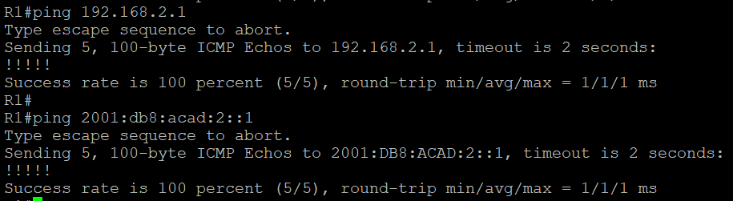

**IPv4 and IPv6 Ping from Router 1 to Router 6:**

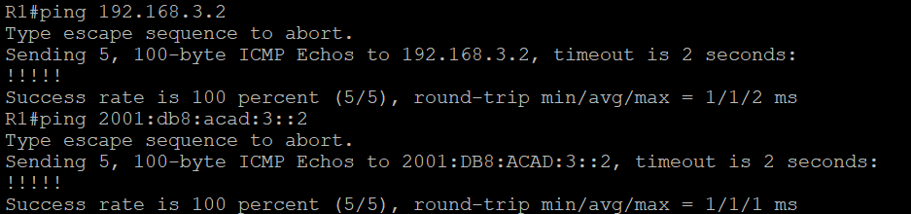

**IPv4 and IPv6 Ping from Router 3 to Router 6:**

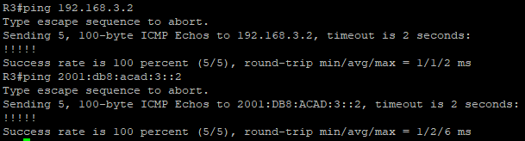

**IPv4 and IPv6 Ping from Router 6 to Router 1:**

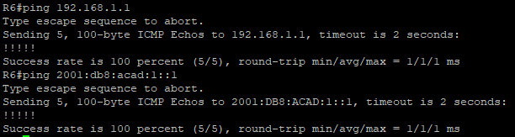

**IPv4 and IPv6 Ping from Router 6 to Router 3:**

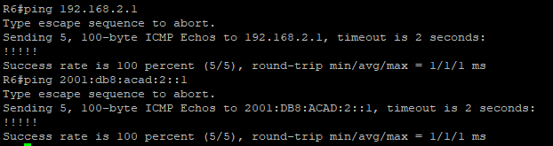

**Router 1 IPv4 and IPv6 Route:**

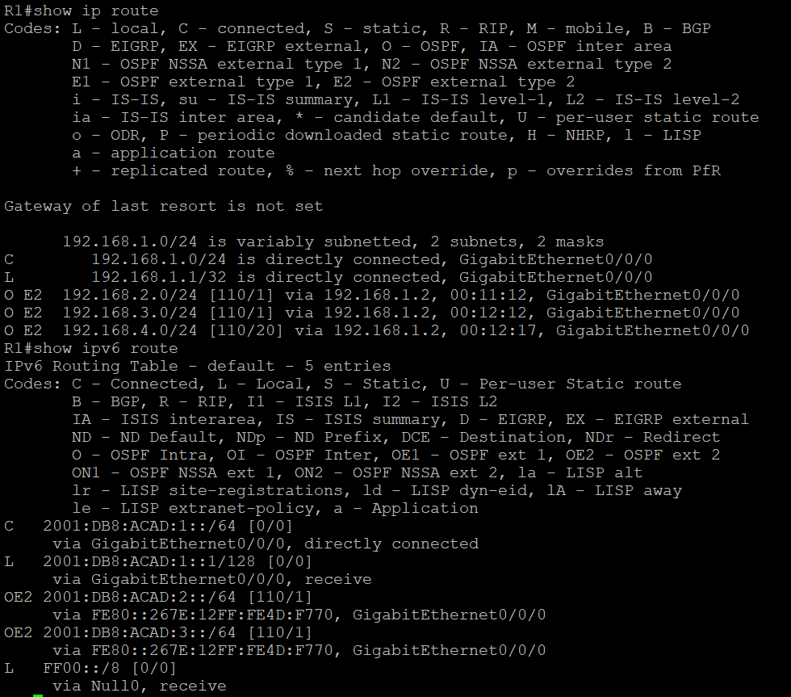

**Router 2 IPv4 and IPv6 Route:**

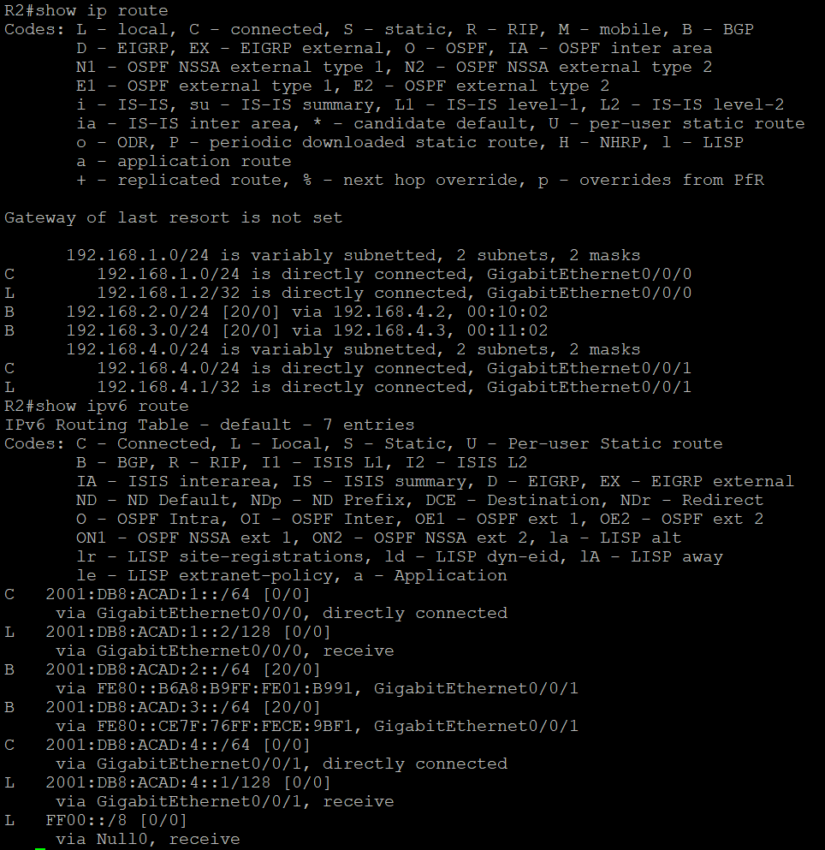

**Router 3 IPv4 and IPv6 Route:**

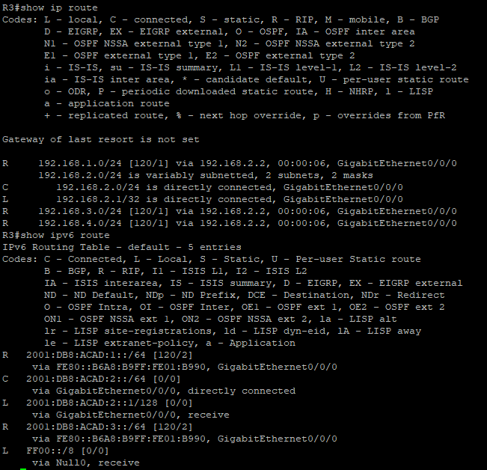

**Router 4 IPv4 and IPv6 Route:  
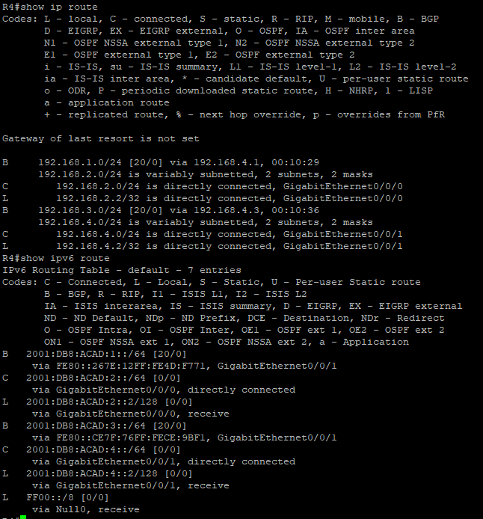**

**Router 5 IPv4 and IPv6 Route:**

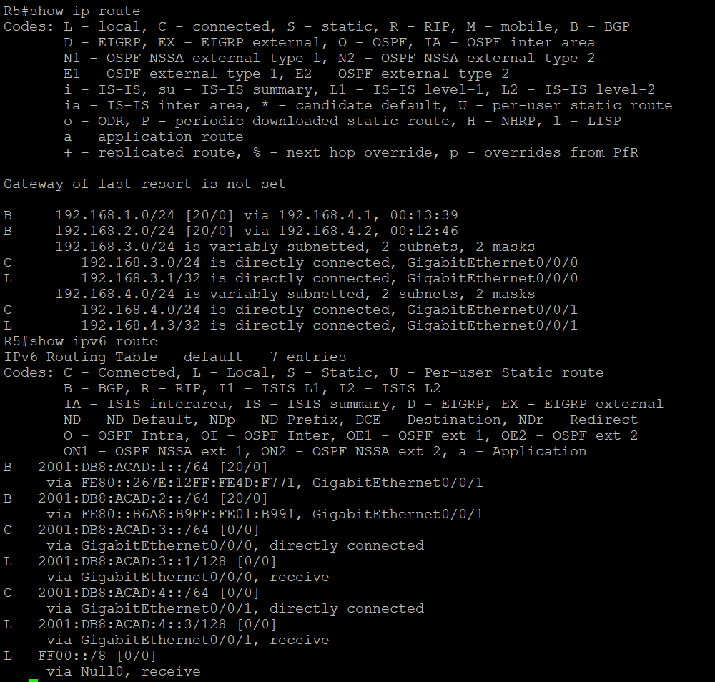

**Router 6 IPv4 and IPv6 Route:**

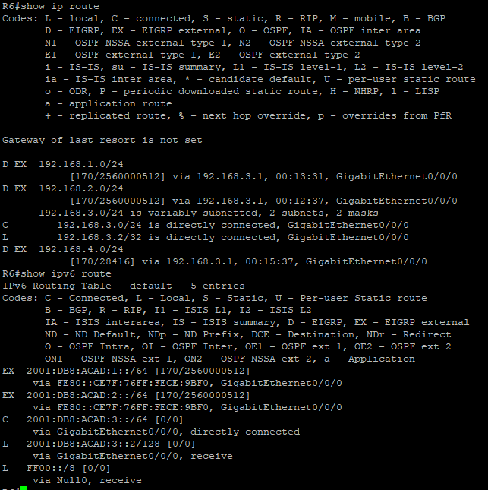

**Problems:**

One of our main problems in this lab we weren’t able to reach full connectivity between all routers using different protocols. We first realized that we were entering the command “redistribute connected” but was only applying the command on a direct link. For interconnectivity we had to enter the redistribute command to the specific protocols (for OSPF, EIGRP, RIP, BGP). Since we didn’t have connectivity between different areas for IPv4, we found that we didn’t have neighbor activate commands and that we still had to enter redistribute connected commands on the edge routers. When we were entering show BGP commands, we had no BGP routes. In turns out that we were missing BGP router-ids and router-ids for the other protocols. When configuring router-ids we accidentally configured the router ids for the inner routers higher than the outside routers, which messed up the path selection. Routers will prefer the path with the lowest neighbor router ID first, so we switched them back to make sure the inner router path was preferred before the path to the outer router. We were also missing BGP network commands. When learning the new command to refresh BGP (clear IP BGP), once reset, we were able to get BGP routes in our routing table. When we got stuck, our biggest overarching problem was that we were looking at the commands of our classmates to see what we were missing but didn’t realize that they had only 3 routers while we had 6. Our network scenarios were completely different, so we had to only look into our network design for problems.

**Conclusion:**

Although this lab took us the longest time, I heavily enjoyed the struggles in the process of completing it. I learned that before examining another person’s configurations, we should first see if they have a similar network topology as us. I was able to gain knowledge about key concepts of implementing important routing protocols simultaneously in which I can take with me in the workforce.

**Teacher Signoff:**

 